**CBS Primary School,**

Chapel Street,

Dundalk,

Co. Louth.

A91 YF82

Telephone number: 042 9327861

[office@cbsprimarydundalk.ie](mailto:office@cbsprimarydundalk.ie)

**CBS Primary Dundalk**

**Healthy Eating Policy**

Introductory Statement

This document is a statement of the aims and objectives, principles and strategies for healthy eating in CBS Primary School. It was reviewed during the academic year 2024/2025 through a process of consultation with teaching staff, pupils and parents.

Rationale

Healthy eating policies should outline how the school supports healthy eating practices through the promotion of healthy lunches and healthy snacks. Schools support pupils to develop an understanding of the nourishment of common and easily accessible food products, and facilitate the development of the skills and attitudes to make informed decisions about their food intake. Habits created at a young age continue to inform us throughout life. We are committed to ensuring that our young people have the knowledge and skills to make informed decisions to lead healthy enhancing lifestyles. But such habits must be reinforced by families and their community to make it have a lasting impact.

Vision

CBS Primary School is committed to encouraging and developing positive attitudes towards food and a healthy diet. Promoting a healthy lifestyle is part of the curriculum and we recognise the importance of offering children the opportunity to make informed choices about what and why they eat. As a school we know that food is fundamental to the quality of a child’s life, not just in providing essential nutrition but in communicating and sharing positive values, attitudes and experiences with each other. We believe that adults (staff, parents and carers) should be good role models and should support the children in understanding how balanced nutrition contributes to a person’s health, happiness and general well-being.

Aims/Objectives

To improve the health of pupils and the whole school community by helping to influence eating habits through increasing knowledge and awareness of food issues including what constitutes a healthy diet.

* To promote healthy eating across school life, consistent with national healthy eating guidelines and school curriculum.
* To make the provision and consumption of food an enjoyable and safe experience.
* To ensure pupils are well nourished at school and that every pupil has access to safe, tasty and nutritious food.
* To ensure that lunchtimes in the school acknowledges the ethical and medical requirements of staff and pupils.
* To introduce and promote practices within the school to reinforce these aims.
* To enable the child to accept some personal responsibility for making wise food choices and adopting a healthy balanced diet.
* To encourage and promote the recycling of lunch packaging, the reduction of waste food and the reuse of food containers and bottles.

Organisation/Curriculum

* We regard healthy eating education as a whole school issue and we believe that opportunities to teach about the importance of living a healthy lifestyle occur throughout the curriculum.
* Healthy eating education forms an important part of our school’s curriculum. The importance of balanced nutrition and healthy food choices is explicitly taught through the Science and SPHE curriculum.
* The Math curriculum is also an avenue to explore healthy eating - label reading skills are Math based. (Quantities, serving size, calories etc.)
* Geography might demonstrate the numerous countries that ingredients come from and History could be used to track the origin of certain foods and foods being introduced to Ireland (potato/cultural changes in our food likes/dislikes/availability)
* All pupils have the opportunity to learn about food hygiene and safe food preparation and to learn about where food has come from.
* Pupils learn about the requirements for plant growth, the food chain and the components of a healthy diet through the Science curriculum.
* Through the SPHE curriculum, children will learn about food and nutrition as part of the strand unit: taking care of my body.
* In addition, the P.E. curriculum supports the physical development and fitness levels of the children.

To ensure good concentration, it is important for children to eat a healthy breakfast before coming to school each day. Lunch is an important meal for school going children. It should provide one third of their recommended daily allowance of nutrients without being high in fat, sugar or salt. It should also provide dietary fibre. Pupils’ lunch choices should offer balanced nutrition. We provide hot meals through The Lunch Bag <https://www.thelunchbag.ie/>

A healthy lunchbox includes a helping of food from the bottom four shelves of the food pyramid, as per the suggestions in the below picture taken from the SAFEFOOD/HSE healthy lunchboxes leaflet.

## 

The school encourages children to bring only water and milk to school. Milk is an excellent source of calcium which is the main mineral present in bones and teeth. For children aged 9-18 years, 5 servings of calcium rich foods are recommended due to the importance of this mineral during this life stage. Water will be made available throughout the day/ Pupils are encouraged to bring a bottle of water to school. If children do not drink enough water, they may become dehydrated, thirsty, tired and weak.

## 

**We ask that children do not bring the following to school:**

### Snacks known to be high in sugar, saturated fat, salt, additives and preservatives, including the following:

### Crisps (including crisp-style snacks)

* Fizzy drinks
* Juice drinks/ Squashes
* Sweets
* Biscuits/bars
* Cereal bars
* Chocolate spread
* Sweet baked goods
* Dessert Style Yoghurts
* Processed Fruit Snacks
* Chewing gum
* Nut products (due to allergies)

***Treat Days will only take place on special occasions (decided by the school).***

***As we recognise that there is no such thing as “bad food”, we teach the children to enjoy treats in moderation. Special events such as end of term parties in class are times where food contributes to a sense of celebration/sharing/inclusion. On these occasions, staff will remind the children that this is an “occasional” treat and not “every day” food.***

***We discourage the practice of birthday cakes and birthday treats being brought into the school.***

Teachers and staff will provide positive modelling and support attitudes to encourage healthy eating including providing non-food related rewards. Social rewards which involve attention, praise or thanks are often more highly valued than food rewards.

So as to take a proactive approach to healthy lunches, children will be encouraged at all times to eat healthily. Parents are asked to be aware of the portion size appropriate to the child’s age and all uneaten food will be sent home so parents can monitor food consumption.

**A very simple approach to healthy eating is to use the Food Pyramid**:

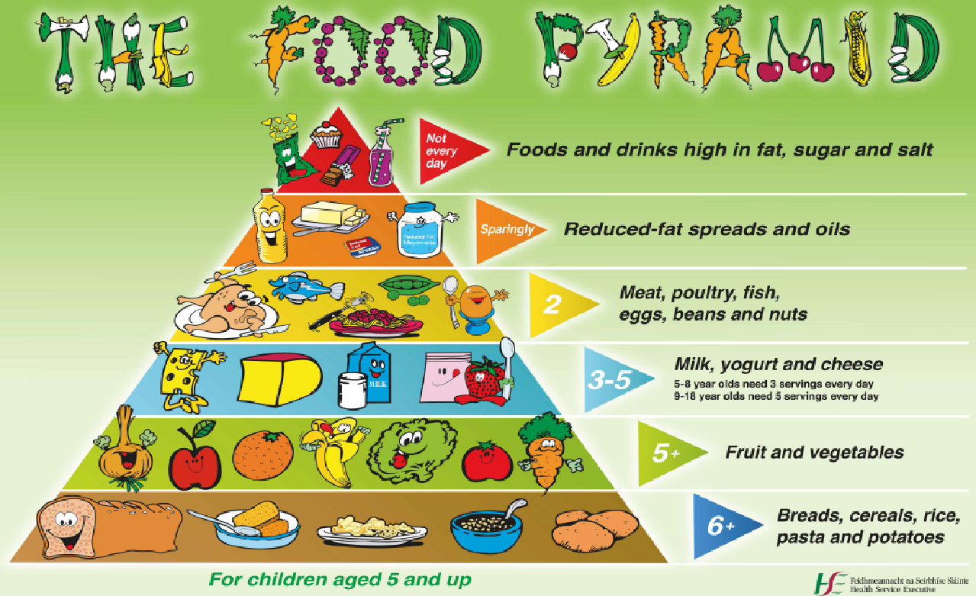

**Green Flag School**

As we are a Green Flag School, children are also asked to:

* take home (in lunchbox) all uneaten food, silver paper, wrappings, containers and cartons
* put only fruit peel into the compost bins
* not bring in cans and glass – for safety reasons.

**N.B. The school community is aware of the possibility of food allergies and special dietary requirements within the school population. Parents or Guardians of children who are on special diets for medical reasons, or who have allergies, will be asked to provide as much information as possible about which foods are suitable or foods which must be avoided.**

Role of Parents

The school is aware that the primary role model in children’s healthy eating education lies with parents. We wish to build a positive and supportive relationship with the parents/guardians of children at the CBS Primary school through mutual understanding, trust and co-operation. In promoting this objective CBS Primary school will:

* Choose a reputable food company to provide nutritious, wholesome lunches made with fresh and good quality ingredients.
* Support parents and their children in making good food choices and provide a balanced, nutritious lunch.
* Inform parents about the school healthy eating education policy and practice. A copy of our policy will be on our school website.
* Support parents to safely manage their child’s food allergies within our school setting.

Benefits of a Healthy Balanced Diet

Eating a healthy balanced diet, along with regular physical activity, is essential for growth, development and general well-being. Benefits of a healthy balanced diet are as follows:

* Improved attention and concentration
* Increased energy levels
* Strong bones and teeth
* Healthy skin and eyes
* Healthy body weight and prevention of obesity
* Increased confidence and self-esteem

Physical Activity

The promotion of physical activity can complement schools’ efforts in relation to promoting healthy eating, as well as promoting pupils’ overall mental health and well-being.4.1 Curricular provision for Physical Education (PE) Principals and Board of Management are reminded that schools are required to provide PE for all pupils. The recommended time currently is one hour of PE per week at all class levels.

Food Dudes

Schools are encouraged to engage with the Food Dudes Programme to support healthy eating and we in the CBS Primary School are participating in this programme. The programme in Ireland is organised by Bord Bia and is funded by the Department of Agriculture, Food and the Marine and the EU School Fruit and Vegetable Scheme. It encourages children to eat more fruit and vegetables at school and at home. Freshly prepared fruit and vegetables are provided free of charge to participating schools.

Reviewing and Evaluation

CBS Primary School will take the initiative in reviewing and monitoring our own practices in these areas through whole-school consultation, reflection and action as part of the school self-evaluation process.

**Implementation and Review**

The Board of Management adopted this policy on ________ 2025.

Signed: Deirdre Kerr, Chairperson, BOM Date: _____________2025.

Signed: Eileen Hart, Principal, Date: _____________2025.

Date of next review: May 2028